Additional Land Requested as part of Community Asset Transfer Request for Duncan Stewart Pavillion by Bonnybridge Youth Football Club.

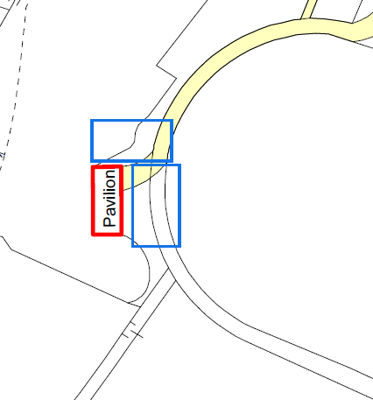
Blue areas in the map above show request for additional land
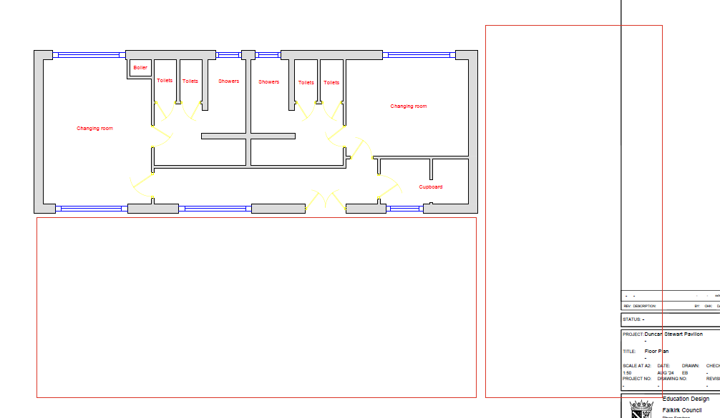
Red areas in the Schematic above show additional land requested

